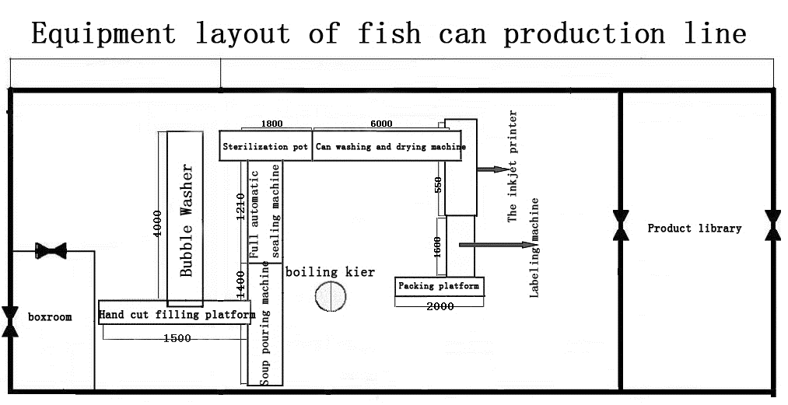
- 不锈钢操作平台（stainless steel operation platform）
设备简介：（Equipment introduction:）
适用于鱼肝的手动切块、手动灌装工作。具有良好的耐腐蚀性，耐脏性，抗冲击性和承重能力强。桌面经特殊处理，具有防腐、抗冲击力强等特点，多种桌面的选择，可配合不同的使用要求。
Suitable for fish liver manual cutting, manual filling work. Good corrosion resistance, dirt resistance, impact resistance and strong bearing capacity. The special treatment of the desktop, with anti-corrosion, impact resistance and other characteristics, a variety of desktop choices, can be used with different requirements.
设备参数：（Technical parameters:）
Model | HS—GZT—2000型
Dimensions | 2000×1000×800（mm）
Motherboard material thickness | 1.5 (mm) 304 stainless steel

设备图片：（Equipment Imag:）
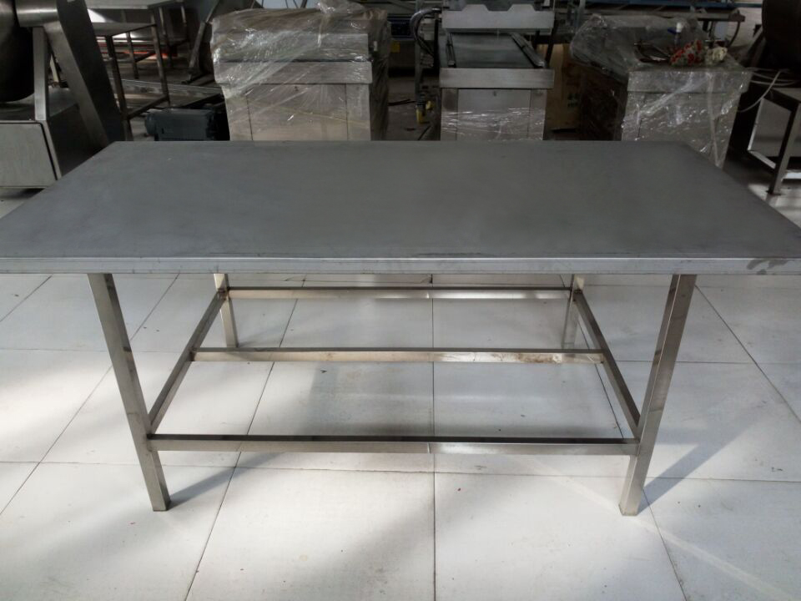
Pictures for reference only
三、煮汤机：（Cooking machine）
设备简介：（Equipment introduction:）
以蒸汽为热源，具有受热面积大、热效率高、加热均匀、加热时间短且温度容易控制，锅体内外壳均为不锈钢材料制造。符合卫生要求并且安全，附件齐全、外形美观、安装及操作简便、安全可靠。
The utility model is characterized in that the utility model has the advantages of large heating area, high thermal efficiency, uniform heating, short heating time and easy temperature control, and the inner and outer shells of the pot body are made of stainless steel material. Comply with health requirements and safety, accessories complete, beautiful appearance, easy installation and operation, safe and reliable.
1、用途：煮汤机（不锈钢夹层锅）又名蒸汽夹层锅,广泛用于糖果,制药,乳品,酒类,糕点,饮料,蜜线,罐头、糕点、莲蓉、豆沙、果酱、酱菜等食品加工,也可用于大型餐厅或食堂熬汤,烧菜,炖肉,熬粥等,是食品加工提高质量,缩短时间,改善劳动条件的优良设备。
1, use: soup machine (stainless steel pot sandwich) aka steam pot sandwich, widely used in pharmaceutical, confectionery, dairy products, wine, cakes, beverages, canned food, cakes, honey, Lian Rong, bean paste, jam, pickles and other food processing, can also be used for large-scale restaurant or Cafeteria cook, stew, soup, porridge. Is the food processing to improve quality, shorten the time, improve working conditions of good equipment.
2、特性：本锅以有一定的压力的蒸气为热源，具有受热面积大，热效率高、加热均匀、液料沸腾时间短。
2, characteristics: the pot with a certain pressure of steam as the heat source, with large heating area, high thermal efficiency, uniform heating, liquid material boiling time is short.
设备参数：（Technical parameters:）
Model | HS-ZT-1500型
Dimensions | 1500×1600×1165（mm）
Steam consumption | 168（L）
Use pressure | 0.3 （Mpa）
power | 1.5（kw）

设备配置：（Equipment configuration:）
锅体 | - 夹层锅内外均为SUS304材质；一次旋压成型  1.The inner and the outer 1 pans of the pot body are both of SUS304 material and one spinning forming  - 架体：全钢夹层锅为不锈钢材质；  2.frame: all steel sandwich pot for stainless steel material;  - 可倾装置一套。  3.A tilting device.
配件 | 安全阀、压力表、三通、直接，排气阀，疏水阀等  Accessories safety valve, pressure gauge, three way, direct, exhaust valve, steam traps, etc.

设备图片：（Equipment Imag:）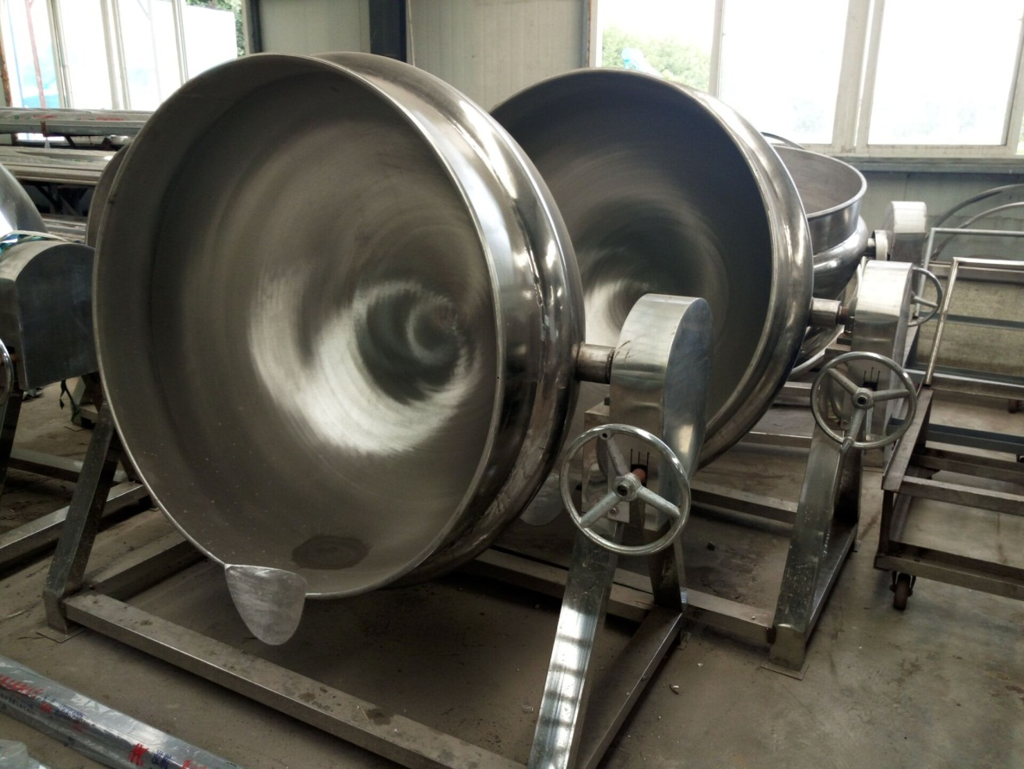
Pictures for reference only

四、注汤机（2个管）+注盐水机：（Soup pouring machine）
设备简介：（Equipment introduction:）
本机器是综合我公司生产多年的灌装生产线之经验，结合国内外同类机型优点，并根据客户工艺要求研制而成。专门针对食品厂的罐头食品而研发的灌装加汤设备。
This machine is the production of our company for many years filling production line experience, combined with the advantages of similar models at home and abroad, and in accordance with the requirements of customer technology developed. Filling and filling equipment specially designed for canned food factory.
设备构造原理：（Equipment construction principle:）
全自动称重式加汤机是通过计量泵给灌装系统完成物料输送，由精密电子秤动态控制装量，实现动态定量加汤灌装。
Full automatic weighing machine is used to complete the material transfer through the metering pump to fill the system, by the dynamic control of the precision electronic scale, to achieve dynamic quantitative filling.
结构紧奏，采用单排输送，电、气控制，自动化程度高。采用高精密电子秤称重模块检测，自动反馈，灌装量误差小，精度高，可根据客户要求及时调节灌装量。系统全部采用PLC可编程控制系统及触摸屏控制，整机运行稳定、可靠。
Compact structure, using a single row of transport, electricity, gas control, high degree of automation. The use of high-precision electronic balance weighing module detection, automatic feedback, filling a small amount of error, high precision, according to customer requirements in a timely manner to adjust the amount of filling. The system adopts PLC programmable control system and touch screen control.
设备特点：（Equipment characteristics:）
1、全程自动，集输送进罐、空罐定位、称重加汤、成品输出于一体，性能稳定。
1, the whole process of automatic, set into the tank, empty tank positioning, weighing plus soup, finished product output in one, stable performance.
2、所有电、气动控制均按国际标准，主要元件采用进口或国产品牌元件，辅助元件采用国内优质产品，采用变频调速，运行速度连续可调。
2, all electrical and pneumatic control are in accordance with international standards, the main components of imported or domestic brand components, auxiliary components using the domestic quality products, the use of variable frequency speed regulation, continuous adjustable speed.
3、接触物料部分管件、阀门、灌装头，均采用优质SS304不锈钢材质；活动部分进料管和输料管采用食品级材质，干净、安全、卫生。
3, the contact part of the pipe fittings, valves, filling head, are using high quality SS304 stainless steel material; active part of the feed pipe and feed pipe using food grade material, clean, safe, sanitary.
4、称重传感器采用品牌单点式铝合金传感器，外部防腐处理。
4, the use of a single point of the load sensor aluminum alloy sensor, external anti-corrosion treatment.
5、灌装头设有防滴漏功能。
5, the filling head is provided with a function of anti leakage.
6、采用西门子PLC可编程控制系统，变频调速，自动化程度高。
6, the use of SIEMENS PLC programmable control system, variable frequency speed control, high degree of automation.
7、多功能保护措施：灌装容器不到位不灌装等。
7, multi-functional protection measures: filling containers are not in place, such as filling.
8、采用西门子触摸屏人机界面控制，方便操作调整。
8, using SIEMENS touch screen man-machine interface control, easy operation adjustment.

PLC控制（PLC control） 触摸屏（Touch screen）
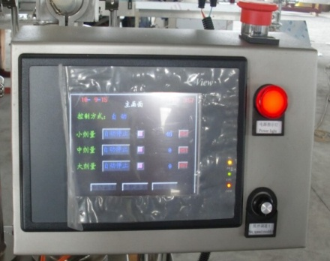
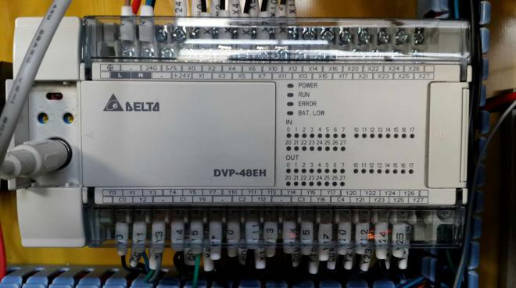
设备参数：（Technical parameters:）
Model | ZTJ-1000型
Overall dimensions (L * w * h) | 1400×900×1600（mm）
power | ≤3（kw）
Number of filling head | 4（个）
Weighing range | 20-50（g）
Throughput | 2400-4800pot/h
Filling Precision | ≤1-2（g）
Power Supply | 380V 50/60Hz

设备图片：（Equipment Imag:）
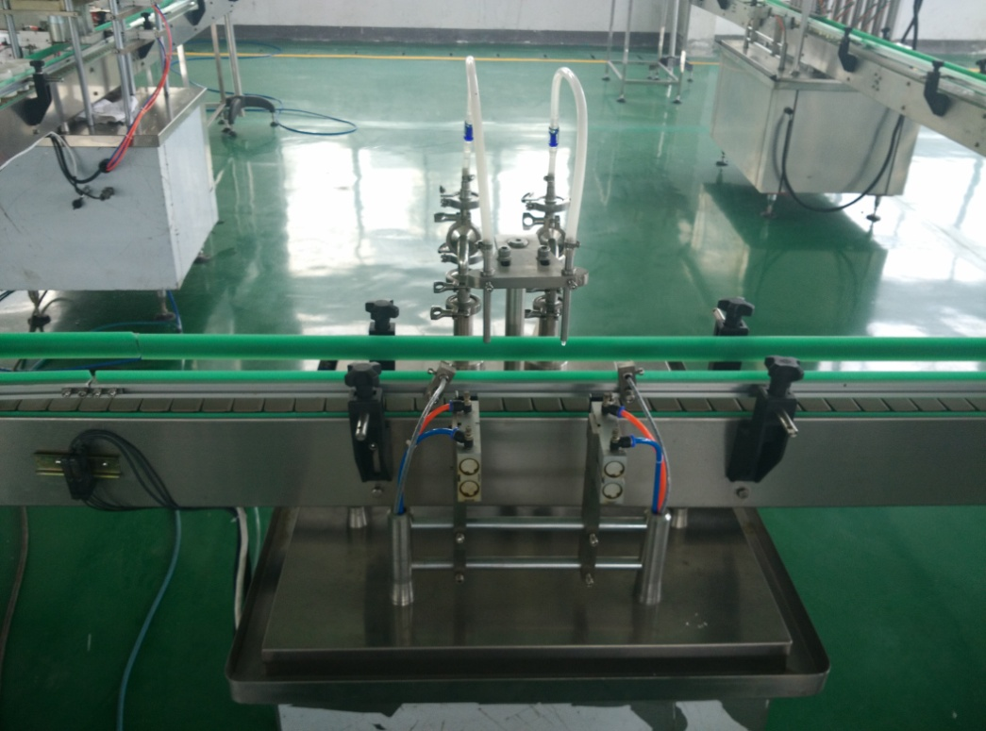

Pictures for reference only

五、全自动封口机：（Full automatic sealing machine）
设备简介：（Equipment introduction:）
产品适用于各种圆形规格的马口铁易拉罐的封口。通过更换压头、转盘、下盖器等相应的配件就可封各种不同规格圆形罐。故本机有生产能力高应、用范围较广、自动化程度高、调整操作方便、使用可靠之特点。适合作为罐头生产线的设备。
Sealing products applicable to all kinds of specifications round tinplate cans. The utility model can be used for sealing various round containers with different specifications by replacing the corresponding parts of the press head, the rotary table and the lower cover. Therefore, the machine has the characteristics of high production capacity, wide application range, high degree of automation, convenient adjustment and operation, and reliable use. Equipment suitable for canning production line.

技术参数：（Technical parameters:）
Model | FKJ-1210型
Dimensions | 1210×1460×1900（mm）
Rated power | 1.5（kw）
Number of cans | 1（个）
Can speed | 756 rev / min
Production capacity | 42 cans / min
Tank height | 50—125（mm）
Suitable | small diameter head 50-70（mm）  Large head70-115（mm）
Voltage three-phase | 380V 50/60HZ
Host weight | about1355（kg）

设备图片：（Equipment Imag:）
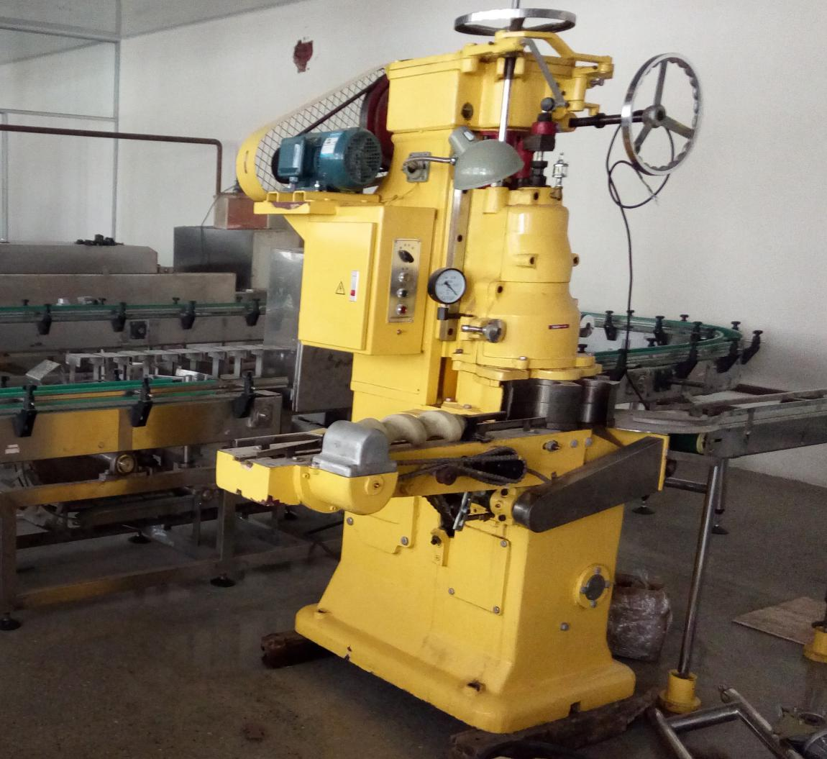
Pictures for reference only
- 双层水浴杀菌锅：（double water bath sterilization pot）
设备简介：（Equipment introduction:）
双层水浴式杀菌锅在工作前可预先把上罐加温到所需温度，把上罐热水迅速放入到下罐内，并根据水泵的流量，蒸汽的流向设置了热水分流器，通过大水泵和大口径管道快速把锅内水经过喷淋装置四面循环一，达到杀菌时无死角，并且可避免食品周围产生过热现象，使食品快速，准确地进行灭菌。特点：高效节能 。双层水浴从材质上分碳刚和304不锈钢两种；从控制方式上分手动、半自动、全自动三种。
The double bath type sterilization pot before work can be put on the tank is heated to the required temperature, the hot water tank quickly put to the tank, and according to the flow of water pumps, steam flow to set up hot water pump through the shunt, and large diameter pipe quickly to the pot of water after spraying device surrounded by a circular, reach sterilization is not dead, and can avoid overheating around food, the food quickly and accurately for sterilization. Features: high efficiency and energy saving. The double bath from the material on carbon steel and 304 stainless steel two; from the control mode manual, semi-automatic and fully automatic three.
适合的产品：肉质品，软包装，马口铁等日产量较大，加工较多肉食品种的客户
Suitable products: meat products, packaging, tinplate, Nissan large amount of processing more carnivorous varieties of customers

技术参数：（Technical parameters:）

Model |  | 900型
Straight tube length |  | 1800 （mm）
Effective volume |  | 1.14（m3）
Total volume |  | 1.37（m3）
Design pressure |  | 0.35（MPa）
Design temperature |  | 147（℃）
处理量 | in bags | 320（kg）
 | Filling (listen) | 1215

设备图片：（Equipment Imag:）
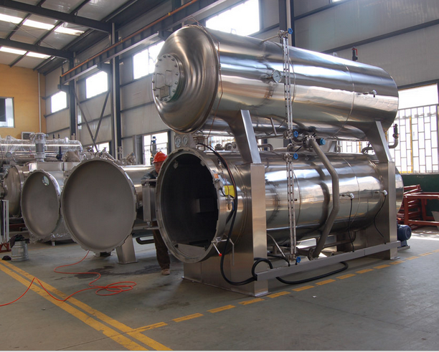
Pictures for reference only

- 罐头清洗烘干一体机：
(Can cleaning and drying integrated machine）
设备简介：（Equipment introduction:）
和硕玻璃瓶清洗风干一体机是通过输送带送至高压喷淋清洗环节，进行全方位往复式喷淋清洗，再进入烘干环节完成对玻璃瓶的烘干作业，从而达到最彻底的清洗烘干效果，减少了人力成本、降低了劳动强度，是食品企业规模化生产的优良帮手。
And the glass bottle dry cleaning machine is through the conveyor belt to the high-pressure spray cleaning process, the full range of reciprocating spray cleaning, and then enters the drying link to finish drying operation for a glass bottle, so as to achieve the most thorough cleaning and drying effect, reduce the labor cost, reducing the labor intensity, is a good helper of food enterprise scale production.
技术参数：（Technical parameters:）
Model | HS-QHJ-6000型
Dimensions | 6000×800×860（mm）
Total power | about30（kw）
Net weight | 400（kg）
Power Supply | 380V/50HZ

设备图片：（Equipment Imag:）
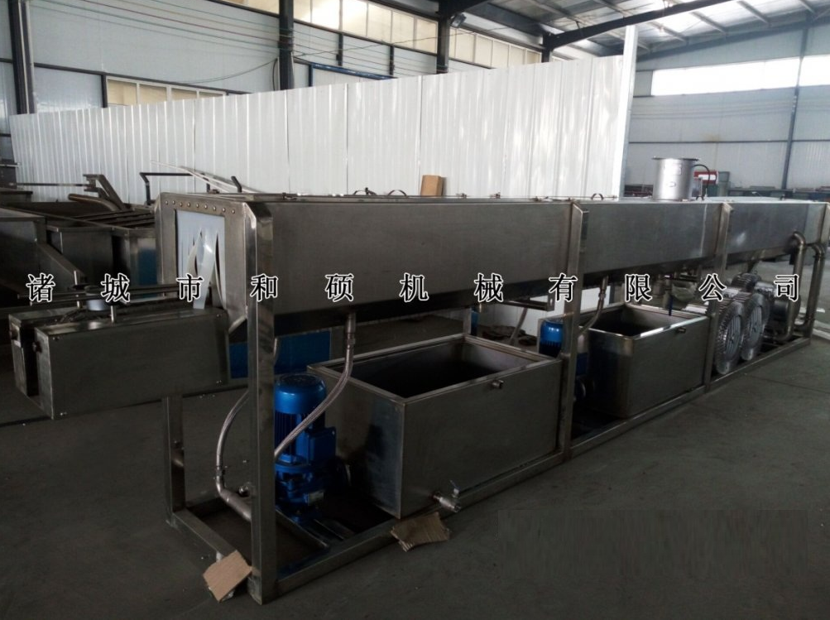
Pictures for reference only

- 喷码机：（Inkjet printer）
设备简介：（Equipment introduction:）
本款全智能型电脑喷码机采用10.2寸真彩LED触摸屏及国际先进的32位ARM嵌入式结构，运行嵌入式linux系统，提供无限制储存文件，在智能与使用方便性与普通电脑一致，并在人机交流和智能操作方面取得巨大的改善。在电路上采用喷码稳定性控制、数据保护等关健技术进行多方面创新和优化设计，在墨路上采用业内先进的隔膜泵四泵一体设计。具有强大的软件编辑功能和极高的稳定性。是技术与性能完美结合的划时代产品。可准确地在食品、饮料、酒类、制药、电线电缆等各种罐装产品、塑料包装、纸质外包装产品等各种不同材料、不同形状物体表面喷印生产日期、保质日期、批号、型号、规格、商标及防伪标识、图文等。
The intelligent computer printer with 10.2 inch color LED touch screen and the international advanced 32 bit ARM embedded structure, embedded Linux operation system, provides unlimited storage file in intelligent and convenient use is consistent with the ordinary computer, and achieved great improvement in man-machine communication and intelligent operation. The jet stability control, data protection and other aspects of the design of Guan Jian technology innovation and Optimization in circuit, used in ink on Design of integrated industry advanced four diaphragm pump. Powerful software editing and high stability. Is the perfect combination of technology and performance of epoch-making products. Can be accurately different in food and beverage, liquor, pharmaceutical, wire and cable etc. all kinds of canned products, plastic packaging, paper packaging products of various materials and shapes the surface printing production date, expiration date, batch number, specifications, and graphic trademark logo.
设备参数：（Technical parameters:）
Model | PMJ-550型
Dimensions | 550×430×280（mm）
power | 0.5（kw）
weight | 35（kg）
ambient temperature | 0-40（℃）
Ambient humidity | 0-90%RH（无结露）
Power Supply | 220 + 10%VAC, 50HZ, 50W good grounding

设备图片：（Equipment Imag:）
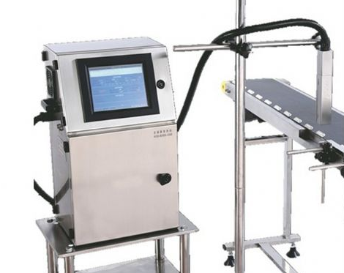
Pictures for reference only

九、贴标机：（Labeling machine）
设备简介：（Equipment introduction:）
该产品适用于制药、食品、日化等行业的圆瓶贴标，可全周贴标和半圆周贴标。可直接连接前端生产线，自动送瓶进入贴标机，增加效率。
Round bottle labeling the product is suitable for pharmaceutical, food, daily chemical industry, the whole week labeling and semi circle labeling. Can be directly connected to the front line, automatic bottle into the labeling machine, increase efficiency.

性能特点：（Performance characteristics:）
1、适用范围广，可满足圆瓶的全周贴标或半圆周贴标；
1, wide application range, can meet the needs of all round bottle labeling or semi circle labeling;
2、应用灵活，瓶子站立式贴标，具备自动分瓶功能，可单机生产，也可接流水线生
2, the application of flexible, bottle stand vertical labeling, with automatic sub function, can be stand-alone production, but also can be connected to the production line
3、智能控制，自动光电追踪，具备无物不贴标；
3, intelligent control, automatic photoelectric tracking, with nothing to label;
4、稳定性高，采用成熟品牌PLC+触摸屏+步进电机+传感器电控系统控制，安全系数高，
4, high stability, the use of mature brand PLC+ touch screen + stepper motor + sensor electronic control system, high safety factor,
5、人机交互界面全中文注释和完善的故障提示功能、操作教导功能；使用方便，维护简单；
5, the man-machine interface of the whole Chinese notes and improve the fault prompt function, operation and teaching function; easy to use, simple maintenance;
6、调整简单，贴标速度、输送速度、分瓶速度可实现无级调速，根据需要进行调整；
6, simple adjustment, labeling speed, conveying speed, the speed of the bottle can be stepless speed regulation, according to the need to adjust;
7、坚固耐用，采用304不锈钢和铝合金制造，符合GMP 认证。
7, durable, 304 stainless steel and Aluminum Alloy manufacturing, with GMP certification.

技术参数：（Technical parameters:）
Model | TBJ-1600型
Dimensions | 1600×900×1500（mm）
power | 0.5（kw）
Marking speed | MAX 30（m/min）
Voltage | 220（v）
weight | 200（kg）

设备图片：（Equipment Imag:）

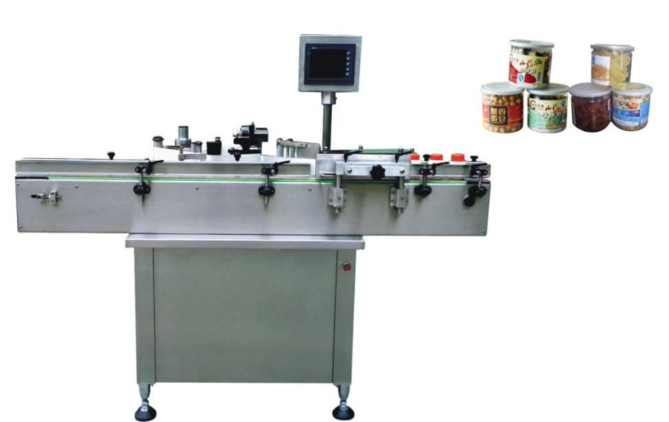
Pictures for reference only

- 手工装箱平台：（manual packing platform）

设备简介：（Equipment introduction:）
适用于鱼肝罐头的装箱工作。具有良好的耐腐蚀性，耐脏性，抗冲击性和承重能力强。桌面经特殊处理，具有防腐、抗冲击力强等特点，多种桌面的选择，可配合不同的使用要求。
Suitable for packing canned fish. Good corrosion resistance, dirt resistance, impact resistance and strong bearing capacity. The special treatment of the desktop, with anti-corrosion, impact resistance and other characteristics, a variety of desktop choices, can be used with different requirements.

设备参数：（Technical parameters:）
Model | HS—GZT—2000型
Dimensions | 2000×1000×800（mm）
Main plate thickness | 1.5 (mm) 304 stainless steel

设备图片：
Pictures for reference only
注：（Note:）
1、此鱼肝罐头生产线设备报价为不含运费、不含税、不含现场安装调试价格。
1, the fish canned food production line equipment price does not include freight, excluding tax, excluding on-site installation and commissioning price.
2、设备生产总工期为45个工作日。
2，Total production period is 45 working days.

